PROJECT REPORT

Sentiment Analysis Using Bag of words Model

Rup Kiran Boyana

Contents

Introduction – 3

Problem Statement – 3

Datasets used – 3

Approach 1 3

Output of the Approach1 - 7

Approach 2 8

Output of the Approach2 – 10

Conclusion – 11

# Introduction –

The sentiment expressed in a piece of text can be determined computationally using sentiment analysis and the BOW model. The bag of words module is frequently used in text mining and natural language processing. In this project, the bag of words technique is used to perform sentiment analysis, with the findings of the analysis being determined by a Naive based classifier.

# Problem Statement –

The bag of words model has some drawbacks, including the inability to take word order or semantics into account when expressing text as a collection of individual words. This restriction can be important since the meaning and context of the text can be affected by the order of words in a sentence as the words around them might change or reverse the meaning. The sentiment of each word or token is ascertained by sentiment analysis. Because of the constraints of the bag of words model, performing sentiment analysis using this method will change how words are perceived. Here, we will use the bag of words technique to analyze the sentiment of various social media comments. Based on the results We will be able to determine whether the bag of words model could be employed for sentiment analysis and whether it produces reliable results given its constraints based on the analysis's findings.

# Datasets used –

I used two separate sets of data. To generate one of the data sets, I collected both positive and negative reviews of the Star Wars films. The second dataset, which I acquired from Kaggle, is about the imdb reviews. Type, reviews, and label columns are present in every dataset. The column labels identify reviews as good or negative, the column reviews contain individual reviews of the people, and the column type categorizes the data into train and test data.

# Approach 1

Step1 –

Import all the required libraries to your notebook.

Step2 –

Covert the excel file to .csv format to your notebook, read the csv file and assign it to a data frame object

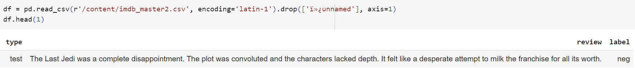

Step3 –

In this step I have assigned value 0 to negative reviews and value 1 to positive reviews from the label column and checked what are the value counts of the required columns.

Step4 –

In this step I have converted all the text data into lower case.

Step5 –

In this step I am eliminating the English stop words from the text data. Here the split method splits the text into individual words and checks if it is not in the English stop words and later the join method combined the words.

Output –



Step6 –

In this step we are performing lemmatization on the nonStpwrds and are stored in a new column named lemmatizedWrds.

Output –

Step7 –

In this step we are dropping columns review, review_lower and nonStpWrds, renaming the lemmatizedWrds column as reviews and stored in the data frame filtered.

Output –



Step8 –

In this step we are selecting rows where the value in the type column is train and test and then dropping the type column from the data frame, later assigning the data to the newly created train and test data frames.

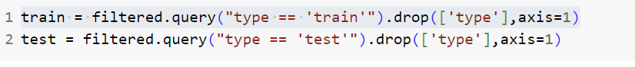

Step9 –

In this step I have created x_train, y_train, x_test, y_test variables and selecting review and label columns from the data frames train and test and then storing there values in the newly created variables.

Step10 –

In this step I have created instance of CountVectorizer and called fit and transform methods on the x_train variable to fetch the words out of x_train and making features and later converting it to the numeric representation.

Step11 –

In this step I have created instance of MultinomialNB, later using the fit method and there by passing the trained_vector and y_train details to train the model.

Step12 –

In this step transform method is used to converting the extracted data into the numeric representation and later stored in the test_vector variable. In the second line of code the model.predict() function takes this test data as input and returns the predicted labels for each data point in the test set.

Step13 –

In this step I have used classification_report() method from the sklearn library to generate an comprehensive report based on true labels and the predicted labels.

# Output of the Approach1 -

Dataset -1

Dataset – 2

# Approach 2

After step 7 from approach1 I have worked on identifying parts of speech of every word from the reviews. For this I have created a column tokens and using nltk.word_tokenize I have tokenized the sentences into words. Later created a new column posTags and using nltk.pos_tag determined the parts of speech for every single word.

In this step I have created a pos_to_keep variable and stored them as a list by only selecting pos taggings that are used for sentiment analysis. The below used pos tags are related to Nouns, Verbs, Adjectives, Adverbs and Pronouns. Later I have created columns filteredPosTags and filteredWords and using lambda function determined each list in this column includes only the POS tags that are present in the pos_to_keep list and each list in this column includes only the words whose POS tags are present in the pos_to_keep list.

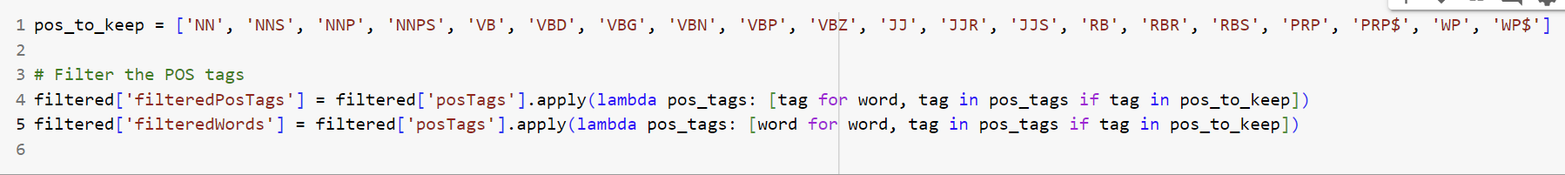

In this step using drop method I have eliminated unnecessary columns and renamed filteredWords column as review column.

In step10 and step12 from approach1 I have created a combined_text variable and later using join method this list comprehension takes each text in x_train and x_test which is a list of sentences or documents, and joins the words in each text using a space as a separator and stored in the combined_text.

In step12 from approach1 have added the below code

# Output of the Approach2 –

Dataset -1

Dataset -2

# 

# Conclusion –

By identifying and avoiding the model's limitations through case conversion of the text, eliminating stop words, lemmatization of the words, and finding accuracy using naive based model, the methods and techniques used in this paper have improved the accuracy of the Bag of Words model to determine sentiment analysis. The accuracy of the results was also improved by using specific parts of speech. If we compare the output results using the first approach and second approach, approach ones 1's precision, recall, f-1 score, and accuracy are significantly lower. This is made possible by incorporating specific speech patterns into our approach two, which increases the model's overall accuracy.